UNITED STATES
SECURITIES AND EXCHANGE COMMISSION
WASHINGTON, DC 20549

FORM 8-K

CURRENT REPORT
Pursuant to Section 13 OR 15(d) of The Securities Exchange Act of 1934

Date of Report (Date of earliest event reported): July 15, 2026

AZITRA, INC.
(Exact name of registrant as specified in its charter)

Delaware |  | 001-41705 |  | 46-4478536
(State or other jurisdiction |  | (Commission |  | (IRS Employer
of incorporation) |  | File Number) |  | Identification No.)

21 Business Park Drive
Branford, CT 06405
(Address of principal executive offices)(Zip Code)

(203) 646-6446
(Registrant’s telephone number, including area code)

(Former name or former address, if changed since last report.)

Check the appropriate box below if the Form 8-K filing is intended to simultaneously satisfy the filing obligations of the registrant under any of the following provisions:

☐ | Written communications pursuant to Rule 425 under the Securities Act (17 CFR 230.425)
☐ | Soliciting material pursuant to Rule 14a-12 under the Exchange Act (17 CFR 240.14a-12)
☐ | Pre-commencement communications pursuant to Rule 14d-2(b) under the Exchange Act (17 CFR 240.14d-2(b))
☐ | Pre-commencement communications pursuant to Rule 13e-4(c) under the Exchange Act (17 CFR 240.13e-4(c))

Securities registered pursuant to Section 12(b) of the Act:

Title of each class |  | Trading Symbol(s) |  | Name of each exchange on which registered
Common stock, par value $0.0001 |  | AZTR |  | NYSE American

Indicate by check mark whether the registrant is an emerging growth company as defined in Rule 405 of the Securities Act of 1933 (§230.405 of this chapter) or Rule 12b-2 of the Securities Exchange Act of 1934 (§240.12b-2 of this chapter).

Emerging growth company ☒

If an emerging growth company, indicate by check mark if the registrant has elected not to use the extended transition period for complying with any new or revised financial accounting standards provided pursuant to Section 13(a) of the Exchange Act. ☐

Item 8.01 Other Events.

On July 15, 2026, the Company issued a press release. A copy of the press release is furnished as Exhibit 99.1 to this Current Report on Form 8-K.

Item 9.01 Financial Statements and Exhibits

(d) Exhibits.

99.1 | Press release dated July 15, 2026.
104 | Cover Page Interactive Data File (embedded within the Inline XBRL document)

SIGNATURES

Pursuant to the requirements of the Securities Exchange Act of 1934, the registrant has duly caused this report to be signed on its behalf by the undersigned hereunto duly authorized.

 | AZITRA, INC.
Dated: July 15, 2026 | By: | /s/ Francisco D. Salva
 |  | Francisco D. Salva
 |  | Chief Executive Officer

Exhibit 99.1

Azitra, Inc. Announces Breakthrough Repeat Dose and Anti-Wrinkle Ex Vivo Results for
ATR-COSF Program, Demonstrating Increased Distribution and Elasticity

 | ● | ATR-COSF uses a supernatant based formulation containing an active recombinant human domain of the protein, filaggrin (“rHDfilaggrin”). This S. epidermis derived supernatant is in development as a high value cosmetic ingredient
 | ● | Ex vivo data successfully showed controlled distribution of the rHDfilaggrin into the stratum granulosum in increased amounts over prior single dose experiments in human skin
 | ● | Single dose ex vivo experiments established improvements in elasticity and reduced the appearance of new fine lines and wrinkles in human skin

BRANFORD, Conn. – July 15, 2026 - Azitra, Inc. (NYSE American: AZTR), a clinical stage biopharmaceutical company focused on developing innovative therapies for precision dermatology and high value cosmetic proteins and peptides, today announced promising results from two separate ex vivo human skin tissue studies. The studies evaluated the distribution and anti-wrinkle activity of Azitra’s filaggrin domain containing supernatant in two separate experimental studies.

The ATR-COSF program utilizes the supernatant from a strain of S. epidermidis engineered to secrete a functional unit of the human filaggrin protein. In the first study, ATR-COSF supernatant was found to provide a positive penetration and distribution profile for rHDfilaggrin in a multiple dose, ex vivo model. The study, which utilized fresh, healthy human skin explants, demonstrated a remarkable increase in rHDfilaggrin delivered through the stratum corneum and into the stratum granulosum layers, compared to single dose previous work. Additionally, improved concentration in the stratum corneum and stratum granulosum layers was seen with the formulated product in comparison to concentrated supernatant alone.

The first ex vivo model offers a biologically relevant system for evaluating skin penetration while preserving the architecture of human skin. The healthy human skin explants were first stimulated with TH2 cytokines to reduce the levels of endogenous filaggrin in the samples. The study used a 2% lyophilized supernatant in a hydrogel formulation. rHDfilaggrin penetration in the middle to lower stratum corneum was detected following a single application of the 2% formulation. Increased amounts of rHDfilaggrin were observed with additional applications. Safety testing conducted in accordance with standardized guidelines demonstrated that the 2% supernatant formulation is non-irritating and non-corrosive to the skin and eyes.

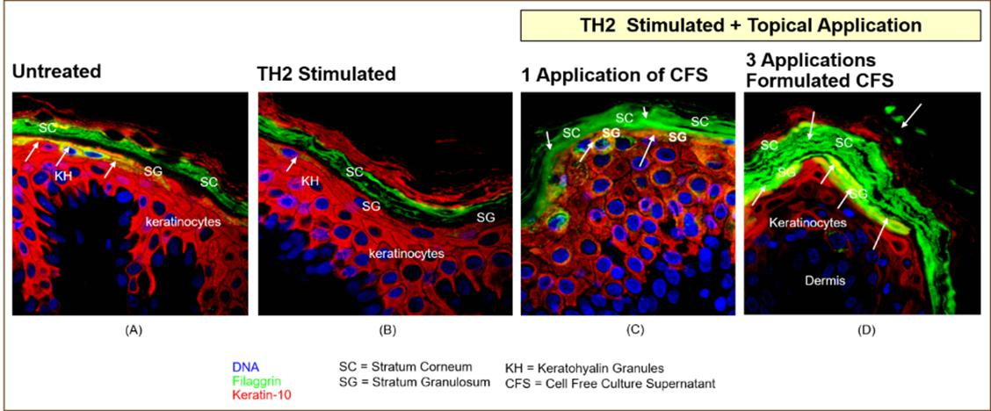

In the figure above, (A) depicts the explanted healthy human skin explant prior to any treatment. Native filaggrin as well as profilaggrin in keratohyalin granules (stained in green) are apparent in the stratum granulosum (SG) layer. (B) shows the skin sample after TH2 cytokine stimulation to reduce or eliminate native filaggrin in the stratum granulosum layer. Furthermore, TH2 cytokine stimulation markedly reduced the presence of keratohyalin granules, resulting in decreased endogenous filaggrin. This reduction facilitates the differentiation and detection of rHDfilaggrin following application. (C) shows penetration and distribution of rHDfilaggrin into the stratum granulosum layer after one application of the cell free supernatant. (D) shows penetration and distribution of rHDfilaggrin into the stratum granulosum layer after three applications of the lyophilized cell free supernatant in a hydrogel formulation.

The second ex vivo model utilized defatted human skin explants to assess the effect of the lyophilized rHDfilaggrin supernatant in a hydrogel formulation on human skin elasticity. Concentrations of the supernatant in the hydrogel were varied from 0.0% to 7.5% (weight/weight or “w/w”). Elasticity was measured at 20 hours post application. Skin samples were incubated at 30ºC. The hydrogel alone results are shown in open circles and the active are in black squares.

Human Skin Elasticity Measurement vs Supernatant Concentration

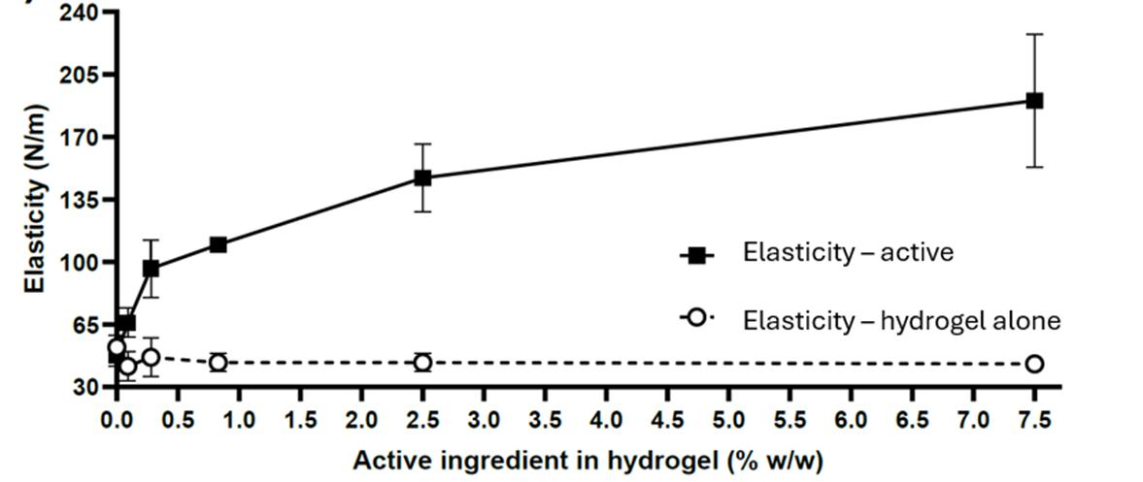

The hydrogel containing the lyophilized supernatant was active in increasing the elasticity of ex vivo human skin sections in a dose-dependent manner. Minimal and maximum effects in elasticity enhancement were observed in hydrogels containing 0.09% w/w (1.6-fold) and 7.5% w/w (4.4-fold) of active ingredient, respectively. Hydrogels containing 0.28% w/w of active ingredient restored ex vivo abdominoplasty skin elasticity to values historically observed in healthy skin. Pictures taken of skin samples after the incubation period treated with placebo or the 0.3% w/w supernatant hydrogel are shown below. The active treated sample showed approximately two times the elasticity compared to the placebo treated skin sample, highlighting the formulation’s potential as a novel cosmetic ingredient for improving skin firmness and resilience.

Placebo Treated |  | Active Treated – 0.3% Supernatant
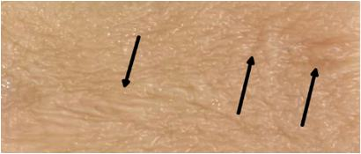 |  | 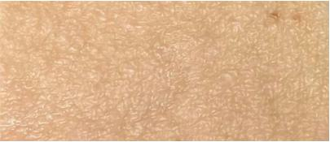

“Our team at Azitra continues to be highly motivated by the prospects of our ATR-COSF program and its potential to have a substantial effect on improving the appearance of fine lines and wrinkles. Our plan is to continue to optimize our formulations and test on additional ex vivo human wrinkle models as we head towards starting our human study, which is being designed to translate our cutting edge science into observable, visible wrinkle reduction benefits for consumers,” said Francisco Salva, CEO of Azitra. “Filaggrin is a protein that is critical to the maintenance of our skin’s elasticity and pliability and overall healthy appearance.”

About Azitra, Inc.

Azitra, Inc. is a clinical-stage biopharmaceutical company focused on developing innovative therapies for precision dermatology and novel products across therapeutics, cosmeceuticals and biotechnology applications. The Company’s portfolio is highlighted by ATR-COSF, a recombinant protein technology designed for cosmetic and skincare applications, and ATR-04, an investigational live biotherapeutic for EGFR inhibitor (“EGFRi”) associated rash. Azitra has received Fast Track designation from the FDA for EGFRi associated rash, which impacts approximately 150,000 people in the U.S. Azitra is also advancing additional recombinant protein initiatives designed to support biotechnology research and manufacturing applications. Azitra’s technology platforms combine engineered proteins, topical live biotherapeutics, artificial intelligence, and a proprietary microbial library to develop differentiated products for consumer, research and healthcare markets. For more information, please visit https://azitrainc.com.

Forward-Looking Statements

This press release contains forward-looking statements within the meaning of the Private Securities Litigation Reform Act of 1995, as amended. These statements may be identified by words such as “aims,” “anticipates,” “believes,” “could,” “estimates,” “expects,” “forecasts,” “goal,” “intends,” “may,” “plans,” “possible,” “potential,” “seeks,” “will,” and variations of these words or similar expressions that are intended to identify forward-looking statements. Any such statements in this press release that are not statements of historical fact may be deemed to be forward-looking statements. These forward-looking statements include, without limitation, statements regarding the expected timing of (i) our provision of initial safety data and topline results for the Phase 1b trial for our ATR-12, (ii) the abstract detailing the Phase 1/2 clinical trial for our ATR-04 program, (iii) our provision of initial safety data and topline results for the Phase 1/2 clinical trial for our ATR-04 program, and (iv) statements about our clinical and preclinical programs, including ATR-COSF, and corporate and clinical/preclinical strategies, including our cosmeceutical strategy.

Any forward-looking statements in this press release are based on current expectations, estimates and projections only as of the date of this release and are subject to a number of risks and uncertainties that could cause actual results to differ materially and adversely from those set forth in or implied by such forward-looking statements. These risks and uncertainties include, but are not limited to: the timing of clinical trials and their results; we may experience delays in the provision of initial safety data and topline results for ATR-COSF, ATR-12 and ATR-04 and, if we do, such data and results may not be favorably received; the safety and efficacy of our product candidates; possible delays in regulatory approval or changes in regulatory framework that are out of our control; our estimation of addressable markets of our product candidates may be inaccurate; we may fail to timely raise additional required funding; more efficient competitors or more effective competing treatment may emerge; we may be involved in disputes surrounding the use of our intellectual property crucial to our success; we may not be able to attract and retain key employees and qualified personnel; earlier study results may not be predictive of later stage study outcomes; and we are dependent on third-parties for some or all aspects of our product manufacturing, research and preclinical and clinical testing. Additional risks concerning Azitra’s programs and operations are described or incorporated by reference in our annual report on Form 10-K filed with the United States Securities and Exchange Commission (the “SEC”) on February 27, 2026 and our quarterly report on Form 10-Q filed on May 13, 2026 with the SEC. Azitra explicitly disclaims any obligation to update any forward-looking statements except to the extent required by law.

Contact

Norman Staskey
Chief Financial Officer
staskey@azitrainc.com

Investor Relations

Tiberend Strategic Advisors, Inc.
David Irish
231-632-0002
dirish@tiberend.com

Media Relations

Tiberend Strategic Advisors, Inc.
Casey McDonald
646-577-8520
cmcdonald@tiberend.com

SOURCE Azitra, Inc.

